

**PROJECT PLAN AND FIRST INCREMENT REPORT**

**SPRING 2017**

**Team – 1**

**Sarda, Devender – 82  
 Nageswara Rao Nandigadam – 61  
 Syed Moin – 86  
 Chakilam, Revanth – 9**

**Table of Contents**

1. Project Goals and Objectives………………………………………………………3
2. Project Plan and Management……………………………………………………4
3. First Increment Report……………………………………………………………….6
   1. WireFrames………………………………………………………………………..6
   2. Architecture Diagram………………………………………………………….8
   3. Class Diagram……………………………………………………………………..9
   4. Sequence Diagram…………………………………………………………….10
   5. Implementation………………………………………………………………..11
   6. Unit Test Cases………………………………………………………………….15
4. Technicality……………………………………………………………………………….17
5. Bibliography………………………………………………………………………………18
6. **Project Goals and Objectives**

**Motivation:** In today’s busy-busy world, it’s hard to stay fit and keep track of what we should eat and what we shouldn’t. With this underlying motivation, we came up with an idea to create an application which helps you do just that. Stay fit by keeping track of your eating habits and exercise routines.

**Significance:** Though we have multiple applications on fitness and nutrition in the market place, this application stands out as it combines both the dietary plan and exercise routine which a user can follow to make a healthy living and also we have put image recognition functionality which is not available in many of the applications today.

**The Objective:** The objective of this application is to make people fit and make them follow a diet for a healthy lifestyle.

**System Features:**

1. Register & Sign Up Option.
2. Create a plan for individual user.
   1. We will take weight and height of the user while doing registration and set target for day, week and month.
3. Track user calories based on Food + Exercise = Total Calories.
4. Display user progress with intuitive graphs and charts.
5. Image Recognition: User can upload images of food item’s he/she consumes, and our application calculates the approximate calories based on the image and food.
6. Exercise
   1. User has an option to select different exercises and enter inputs to track calories burned.
7. Pie chart
   1. You will have pie chart that for calories from meals. i.e. Breakfast, lunch and dinner.
8. **Project Plan and Management**
9. **Tasks and Issues Screenshot:**

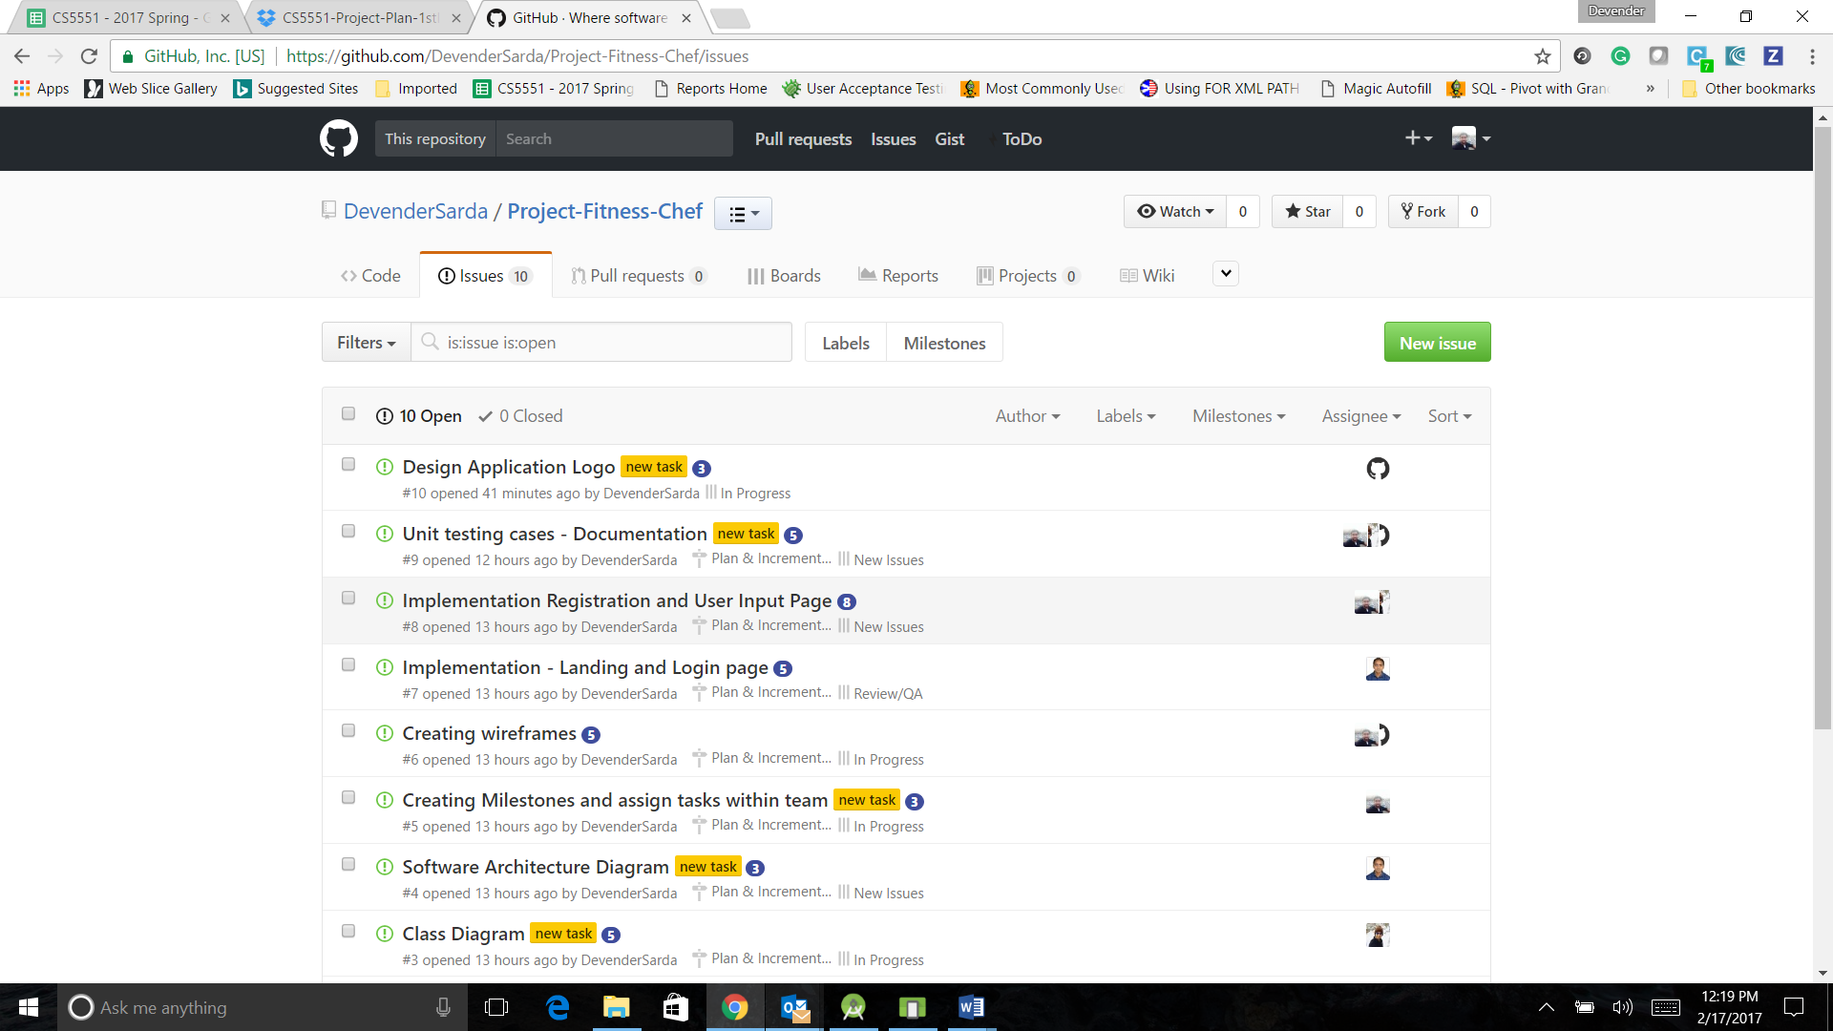

1. **Project Timelines and Task Responsibility**

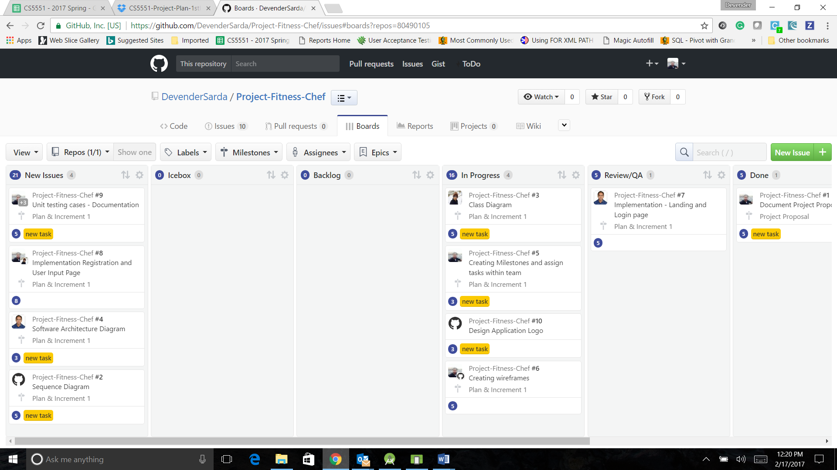

1. **Burn Down Chart**

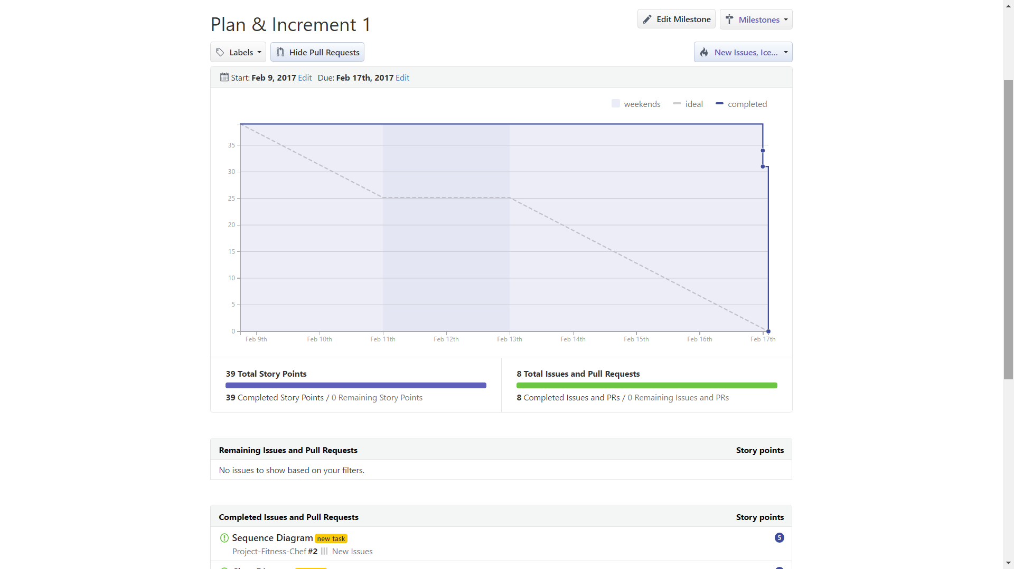

**3. First Increment Report**

**You all fill this section**

1. **Technicality**

**Status Report:**

**Technologies Used:** Android SDK, J2EE, HTML5, CSS, Bootstrap, JavaScript, jQuery, Angular JS, Mongo DB.  
  
**Completed Word:**

1. Architecture of the application
2. Design, Class and Sequence Diagram of the application
3. WireFrames of the application
4. Implementation of Login and Registration page on Android.

**Individual Contributions:**

1. **Bibliography**

<https://developer.edamam.com/edamam-nutrition-api>  
https://www.nutritionix.com/